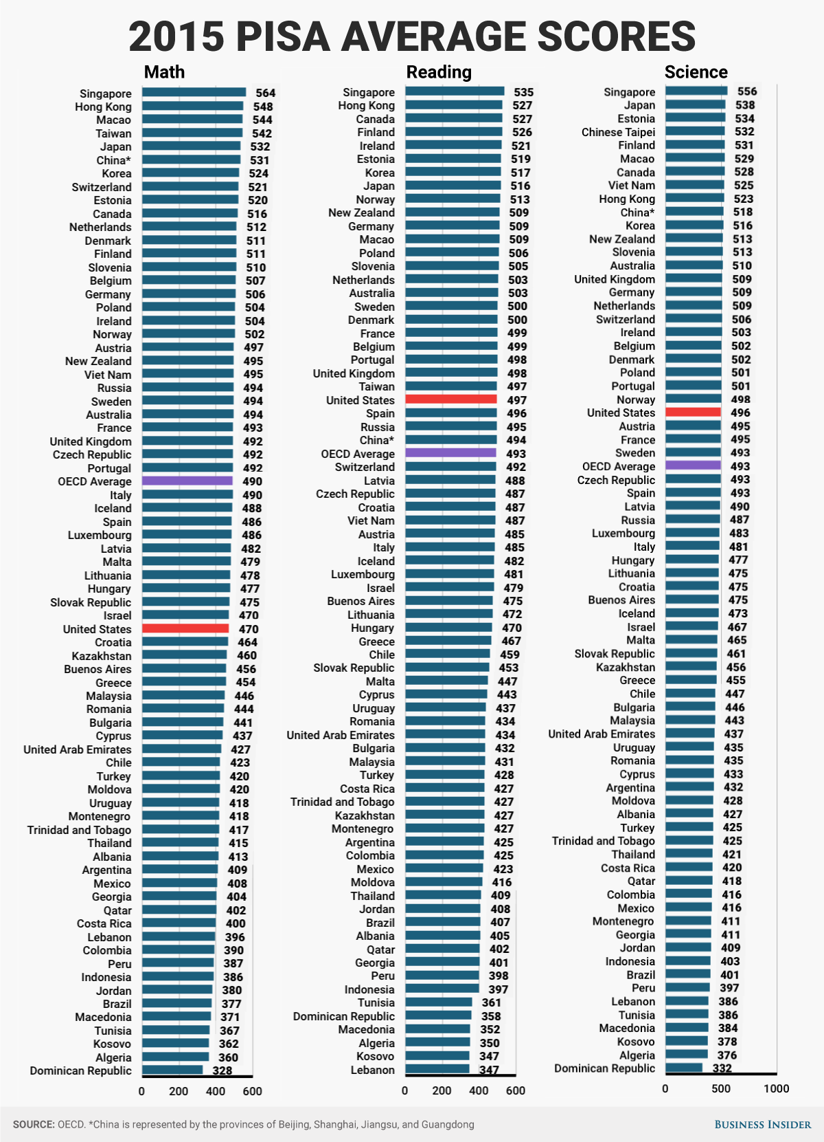

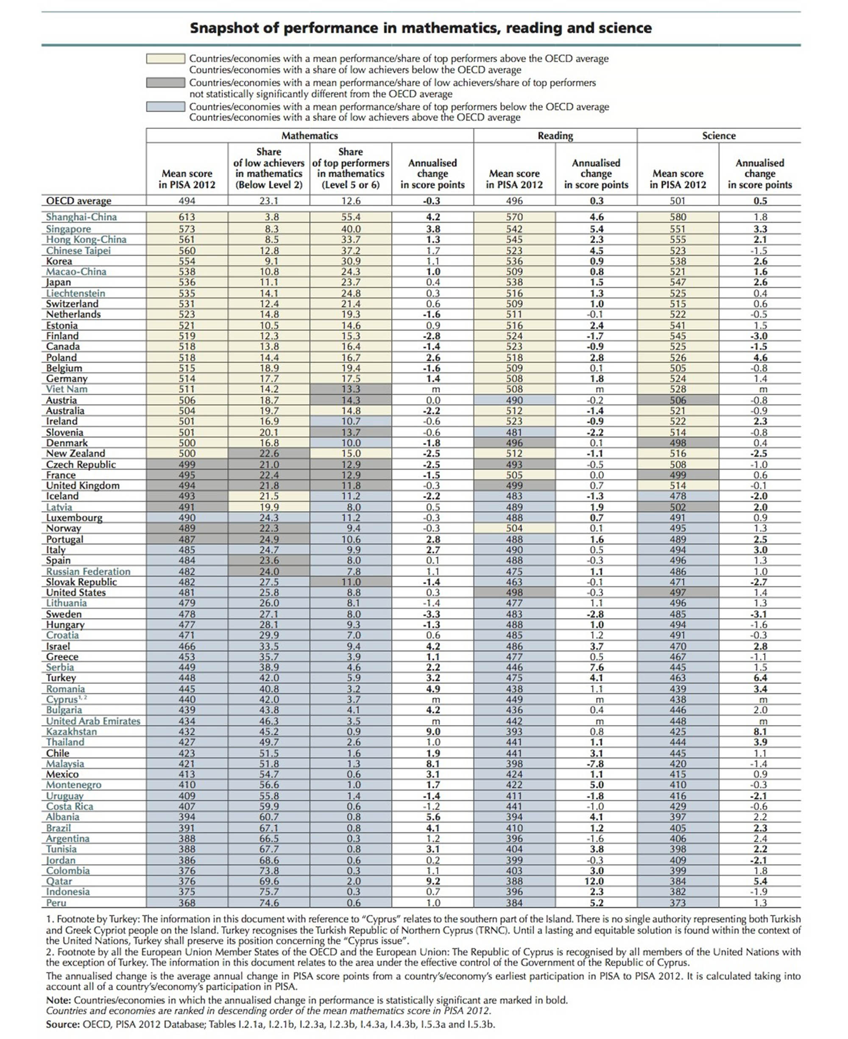

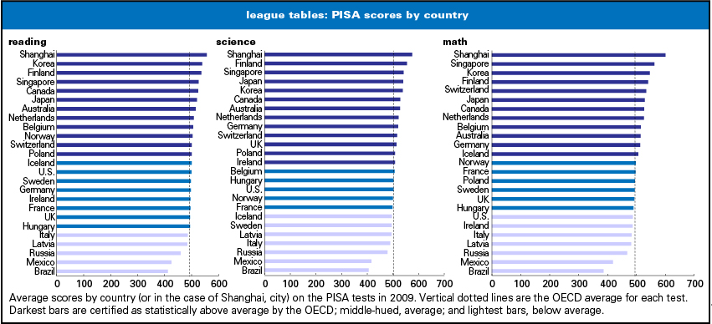

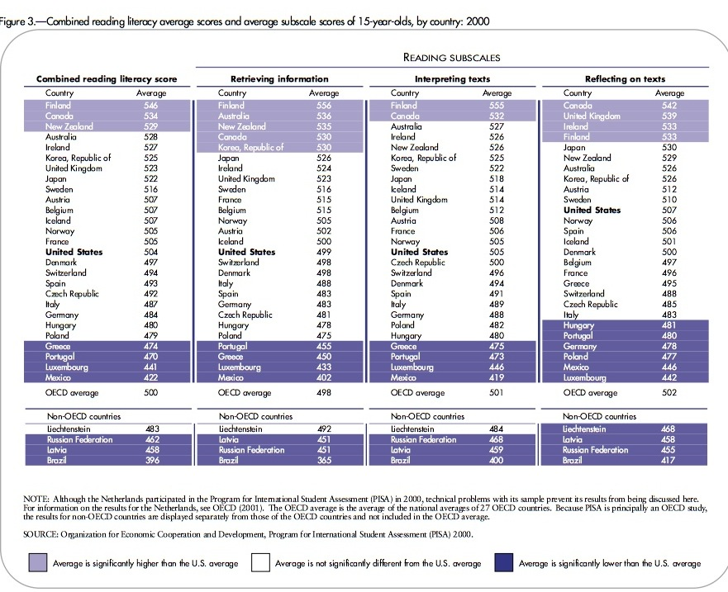

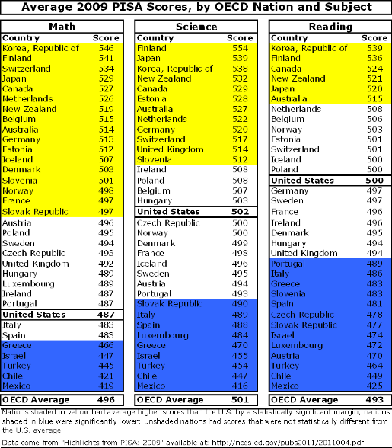

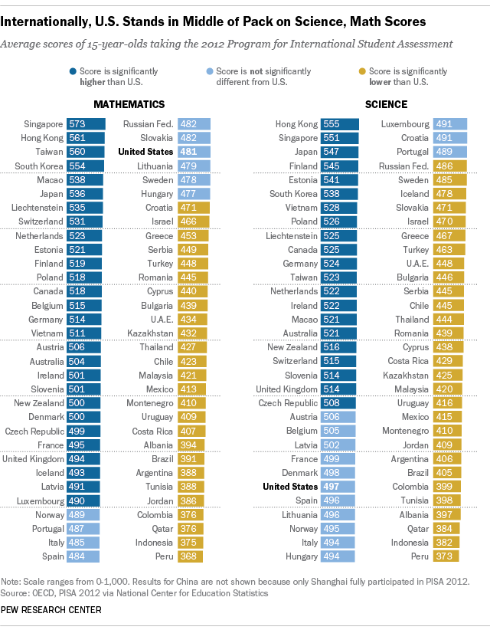

PISA secondary education test results:

<http://www.oecd.org/dataoecd/34/60/46619703.pdf>

|  |  |  |  |  |  |  |
| --- | --- | --- | --- | --- | --- | --- |
| 2009  Programme for International Student Assessment — test scores | | | | | | |
| # | Reading – Overall | | Mathematics | | Science | |
| 1 | China: Shanghai | 556 | China: Shanghai | 600 | China: Shanghai | 575 |
| 2 | Korea | 539 | Singapore | 562 | Finland | 554 |
| 3 | Finland | 536 | Hong Kong | 555 | Hong Kong | 549 |
| 4 | Hong Kong | 533 | Korea | 546 | Singapore | 542 |
| 5 | Singapore | 526 | Chinese taipei | 543 | Japan | 539 |
| 6 | Canada | 524 | Finland | 541 | Korea | 538 |
| 7 | New Zealand | 521 | Liechtenstein | 536 | New Zealand | 532 |
| 8 | Japan | 520 | Switzerland | 534 | Canada | 529 |
| 9 | Australia | 515 | Japan | 529 | Estonia | 528 |
| 10 | Netherlands | 508 | Canada | 527 | Australia | 527 |
| 11 | Belgium | 506 | Netherlands | 526 | Netherlands | 522 |
| 12 | Norway | 503 | China: Macao | 525 | Chinese taipei | 520 |
| 13 | Estonia | 501 | New Zealand | 519 | Liechtenstein | 520 |
| 14 | Switzerland | 501 | Belgium | 515 | Germany | 520 |
| 15 | Iceland | 500 | Australia | 514 | Switzerland | 517 |
| 16 | Poland | 500 | Germany | 513 | United Kingdom | 514 |
| 17 | United States | 500 | Estonia | 512 | Slovenia | 512 |
| 18 | Liechtenstein | 499 | Iceland | 507 | China: Macao | 511 |
| 19 | Germany | 497 | Denmark | 503 | Poland | 508 |
| 20 | Sweden | 497 | Slovenia | 501 | Ireland | 508 |
| 21 | France | 496 | Norway | 498 | Belgium | 507 |
| 22 | Ireland | 496 | France | 497 | Hungary | 503 |
| 23 | Chinese taipei | 495 | Slovak Republic | 497 | United States | 502 |
|  | | | | | PISA  average : | 501 |
| 24 | Denmark | 495 | Austria | 496 | Norway | 500 |
|  | | | PISA  average : | 496 |  | |
| 25 | Hungary | 494 | Poland | 495 | Czech Republic | 500 |
| 26 | United Kingdom | 494 | Sweden | 494 | Denmark | 499 |
|  | PISA  average : | 493 |  | | | |
|  | Reading – Overall | | Mathematics | | Science | |
| 27 | Portugal | 489 | Czech Republic | 493 | France | 498 |
| 28 | China: Macao | 487 | United Kingdom | 492 | Iceland | 496 |
| 29 | Italy | 486 | Hungary | 490 | Sweden | 495 |
| 30 | Latvia | 484 | Luxembourg | 489 | Austria | 494 |
| 31 | Greece | 483 | United States | 487 | Latvia | 494 |
| 32 | Slovenia | 483 | Ireland | 487 | Portugal | 493 |
| 33 | Spain | 481 | Portugal | 487 | Lithuania | 491 |
| 34 | Czech Republic | 478 | Italy | 483 | Slovak Republic | 490 |
| 35 | Slovak Republic | 477 | Spain | 483 | Italy | 489 |
| 36 | Croatia | 476 | Latvia | 482 | Spain | 488 |
| 37 | Israel | 474 | Lithuania | 477 | Croatia | 486 |
| 38 | Luxembourg | 472 | Russian Fed. | 468 | Luxembourg | 484 |
| 39 | Austria | 470 | Greece | 466 | Russian Fed. | 478 |
| 40 | Lithuania | 468 | Croatia | 460 | Greece | 470 |
| 41 | Turkey | 464 | Dubai (UAE) | 453 | Dubai (UAE) | 466 |
| 42 | Dubai (UAE) | 459 | Israel | 447 | Israel | 455 |